**Standard Operating Procedure**

**Dispatch Tipper (By Road)**



**ODISHA MINING CORPORATION LTD.**

**KODINGAMALI BAUXITE MINE**

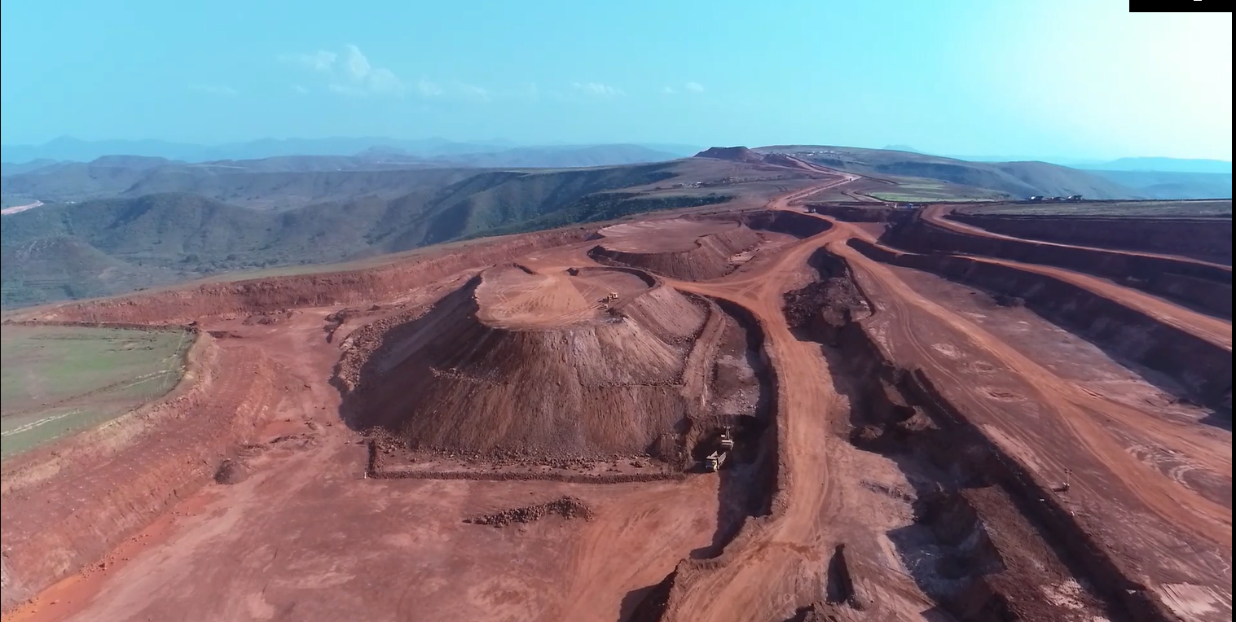

**Authorized By**

1. Before operating your tipper, all the safety devices like Break, Horn, Headlight, Backlight, Indicators and AVA etc. & status of tyres shall be properly examined by the operators.
2. Before the vehicle entry, the security shall check & verify all the valid documents of the vehicle including operator’s skill, loyalty, D.L & age should be above 18 yrs. old.
3. Adolescent operators are strictly prohibited to operate the tipper inside the mines premises. (Age to be verified)
4. While the vehicle approaches to Mines In-Gate, the helper shall be got-down and shall stay at the rest shelter provided by the company.
5. Do not allow any person to ride on the DALA Body in an empty/loaded vehicle.
6. Do not open the door while operating the tipper / vehicle.
7. Before entry the empty vehicle, the security shall check the operator for alcohol test or if any.
8. After alcohol test, if found any operator consumes alcohol, the said vehicle shall immediately be returned and shall not be allowed in to the Mines premises for loading the material and such vehicles shall be suspended and action will be initiated against the operator.
9. The biggest enemies of Operators are Alcohol, High-speed & Overloading.
10. Use mobile phone &Smoking’s are strictly prohibited while operating the vehicle inside the Mines premises.
11. Once, the vehicle is allowed in the entry gate, it shall go to central stock yard through W/B (After Tare Wt.) with a speed of 20KMPH.
12. Any vehicle found to be run speed more than 20KMPH inside the Mines premises, the said vehicle shall be suspended and action will be initiated against the operator.
13. Give clear indication of your direction of the vehicle by use of indicator light at least 30 meters before you make the turn inside the mines premises.
14. The tipper / vehicle shall not be allowed for loading in the mines premises in case of heavy fog or heavy rain. If it is necessary then allow the vehicle with provision of fog light/by use of Dipper light.
15. All the operators are instructed to use Dipper light in night hour operation.
16. Always ensure you’re driving along the normal flow of traffic and try not to violate one-way-traffic movement (where U-turn is allowed)
17. In-side the mine premises, when the vehicle operator using a “Round- About -Traffic, the operator should always ensure that, his taking right of way with indicator in the “Round- About- traffic.
18. One empty/loaded vehicle shall be allowed to park in the mines premises following by “Q – System “at an interval distance of not less than 05 mtrs to the other so as to avoid accident/incidents by dashing with each other.
19. Defensive/control /care driving is the most key to safe travel .Driver should always be alert and aware of the surroundings on the road.
20. Once the vehicle was loaded from central stock yard, the vehicle should follow the traffic system. If any vehicle overtakes another loaded vehicle the said vehicle shall not be allowed for the final weighment and the authority shall have the power to unload the materials immediately and shall exit in empty condition without fail.
21. When the loaded vehicle has got out in the exit gate, the security shall physically check and verify the Regd.no. Types of material taken & other necessary valid documents carrying by the operators and if he satisfies then the vehicle shall be released.
22. The loaded vehicle shall be properly covered with good condition tarpaulin in order to avoid dust pollution, spillage of material and accidents/incidents in the road.
23. When the loaded vehicle crosses/touches State-express highway, Security people will guide/check whether the vehicles are being covered with tarpaulin properly or not and then follow the traffic system in the State -express –Highway.
24. Speed of loaded vehicle plying on the State -express -Highway (Within Lease area) shall not exceed 20KMPH.
25. During checking, if any vehicle found the speed more than 20KMPH, the vehicle Regd. No. Shall be recorded immediately and action will be initiated against the operator.
26. Don’t Double Park your vehicle on the road which will hamper the traffic movement and also a rash / rough riding could damage your vehicle by dashing to the other.
27. Do not be so over smart/ over confident while operating the vehicle.
28. For By-road dispatch, exclusively one W/B shall be used separately in order to avoid traffic congestion so that, the Rly.Siding vehicles shall ply in a smooth manner inside mines premises which shall be controlled & supervised by the security people.